Game Design Document

Fill up the following document

1. Write the title of your project.

Apocalipsis infectado

1. What is the goal of the game?

Llegar hasta la cima de un edifico y poner la cura en un dispositivo que dispersara la cura por el cielo curando a todos los infectados

1. Write a brief story of your game.

Un chica llamada elena ha pasado mucho tiempo escondida de los infectados en su búnker y se ha dado de que hay una cura para los infectados y es su misión llegar hasta ella y salvar a la humanidad de la extinción

1. Which are the playing characters of this game?

* Playing characters are the ones who respond to the user based on the input from the user.
* Cars, monkeys, dinos, wizards, etc., are the playing characters in the game.

|  |  |  |
| --- | --- | --- |
| Number | Character Name | What can this character do? |
| 1 | Elena | Correr hacia adelante o atrás, saltar, agacharse y disparar |
| 2 |  |  |
| 3 |  |  |
| 4 |  |  |
| 5 |  |  |
| 6 |  |  |
| 7 |  |  |
| 8 |  |  |

1. Which are the Non-Playing Characters of this game?

* Non-Playing characters are the ones that don't have an action or behavior when the user interacts with the game.
* Hurdles, stones, bananas, coins, etc., are non-playing characters in the game.

|  |  |  |
| --- | --- | --- |
| Number | Character Name | What can this character do? |
| 1 | Zombie 1 | Perseguirte |
| 2 | Zombie 2 | Saltar, correr, hacia atras o adelante y disparar |
| 3 | Zombie 3 | Saltar, correr, hacia atras o adelante y disparar |
| 4 | Zombie 4 | correr, hacia atras o adelante y disparar |
| 5 |  |  |
| 6 |  |  |
| 7 |  |  |
| 8 |  |  |

Draw your imagination of this game. What does this game look like?

* Draw the game either on your computer or on paper.
* Add images of the game scenes to show each of the playing and non-playing characters at least once.

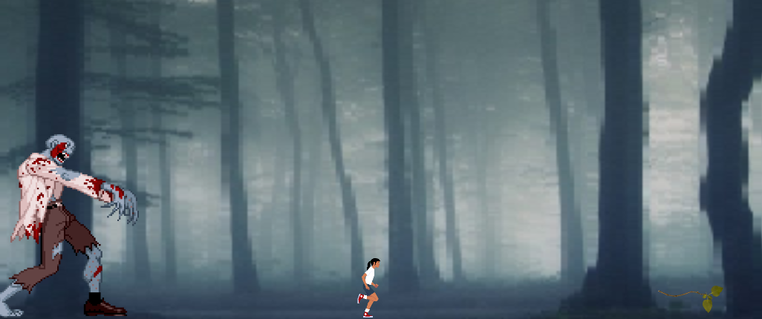

How do you plan to make your game engaging?

Poniendo cierta dificultad pero a la vez diversión en cada nivel de tal manera que no importa cuantas veces pierda las personas que lo jueguen vayan a querer segui jugando